Brief Curriculum Vitae
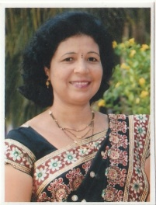

Name | : | Asso. Prof. Neelam Devendra Dhuri
Qualification | : | M.A., M.Phil.
Designation | : | Associate Professor
Date of Birth | : | 10/02/1967
Contact Number | : | 9403562039
Email Address | : | neelamdhuri10@gmail.com
Date of Joining | : | 17/09/1990
Teaching Experience | : | 30 yrs.
Research Experience | : | 8 yrs.
Publications (Papers) | : | Total:- 5 International:- 00 National:- 05
Conferences/Seminar/Workshops | : | Total:- 53 International:- 01 National:- 36 State/ University:- 14
Paper/Poster presentation Awards | : | Total:- 30 International:- 00 National:- 24 State/University:- 06
Book(s) | : | Total:- 02
Book Chapter(s) | : | Total:- 10
Research Projects | : | M phil: Primary Health Centre in Sawantwadi Taluka & Healthy Manpower : One study
Thrust Areas of Research | : | - A study of availability of medical facilities in Sawantwadi Taluka  - Economical Impact of National Highway (Bypass) on Sawantwadi Town  - Ferocement Biogas : Source of Energy
Awards | : | -
Life Memberships | : | - Marthi Arthashatra Parishad  - Nisargrup Paravaran Pratishthan  - Kokan Geographers Association  - Sawantwadi saaunsthan Maratha Samaj, Mumbai  - Maratha Samaj Bandhav Sanghtana, Sindhudurg

